Create Gerber etc files for PCB production

In eagle select the “Cam processor” from the File menu

After the cam processor has loaded from the File menu choose Open->Job

Load the garagedoor-gerb274x.cam file

The will be multiple tabs , each tab represents a section (or a file output).

It will look like this

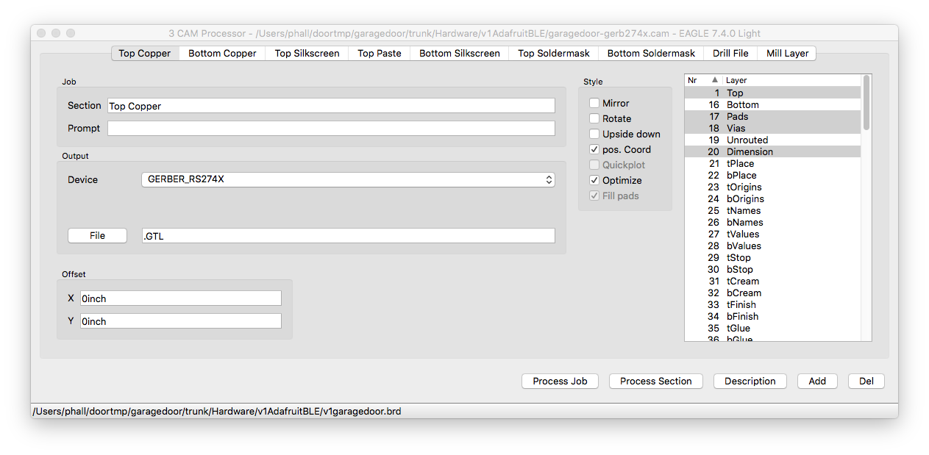

Click on each of the tab and review the settings to match the list below.

Click the ‘Process Job’ button to output the files.

Add the following files into a .ZIP file

V1garagedoor.dri

V1garagedoor.GBL

V1garagedoor.GBO

V1garagedoor.GBS

V1garagedoor.GML

V1garagedoor.GTL

V1garagedoor.GTO

V1garagedoor.GTP

V1garagedoor.GTS

V1garagedoor.TXT

Submitting to advanced circuits

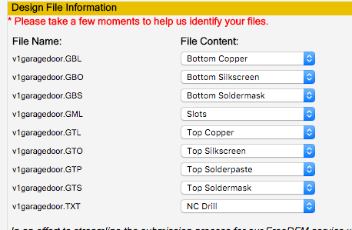

not sure

if the .GML file which is the milling – board cutout – is correctly set for slots.

If the .dri file is required so I’ve not included it here.

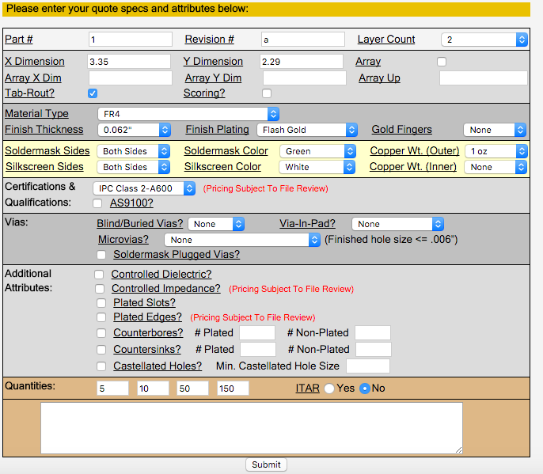

Top Copper

Job

Section: Top Copper

Output

Device: GERBER_RS274X

File : .GTL

Style

Pos.Coord, Optimize

Layers

1 Top, 17 Pads, 18 Vias, 20 Dimension

Bottom Copper

Job

Section : Bottom Copper

Output: GERBER_RS274X

File: .GBL

Style

Pos. Coord, Optimize

Layers

16 Bottom, 17 Pads, 18 Vias

Top Silkscreen

Job

Section: Top Silkscreen

Output

Device: GERBER_RS274X

File: .GTO

Style

Pos.Coord, Optimize

Layers

21 tPlace, 121 _tsilk

Top Paste (not included in the cam file because we do not need a solder stencil)

Job

Section: Top Paste

Output

Device: GERBER_RS274X

File: .GTP

Style

Pos. Coord, Optimize

Layers

31 tCream

Bottom Silkscreen

Job

Section: Bottom Silkscreen

Output

Device: GERBER_RS274X

File: .GBO

Style

Pos.Coord, Optimize

Layers

22 bPlace,122 _bsilk

Top Soldermask

Job

Section: Top Soldermask

Output

Device: GERBER_RS274X

File: .GTS

Style

Pos.Coord, Optimize

Layers

29 tStop

Bottom Soldermask

Job

Section: Bottom Soldermask

Output

Device: GERBER_RS274X

File: .GBS

Style

Pos.Coord, Optimize

Layers

30 bStop

Drill File

Job

Section: Drill File

Output

Device: EXCELLON

File: .TXT

Style

Pos. Coord,Optimize

Layers

44 Drills, 45 Holes

Mill Layer

Job

Section: Mill Layer

Output

Device: GERBER_RS274X

File: .GML

Style

Pos.Coord, Optimize

Layer

46 Milling